Public transportation

optimization



How do you make a transport plan with Python?

**1. Problem Statement**

Retail Stores Distribution with [**Full Truck Load (FTL)**](https://www.youtube.com/watch?v=PYkN24PMKd8)

* **1 Warehouse**delivering stores by using **three** types of Trucks  
  (3.5T, 5T, 8T)
* **49 Stores** delivered
* **12 Months** of Historical Data with **10,000 Deliveries**
* **7 days**a week of Operations
* **23 Cities**
* **84 Trucks** in your fleet

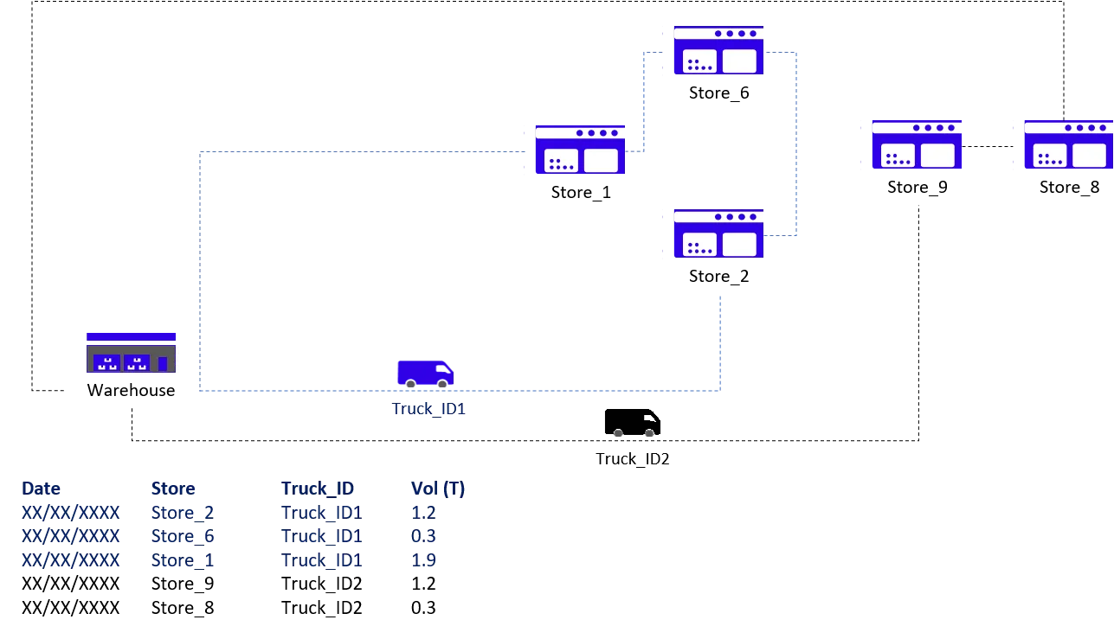

## 2. Objective: Reduce the Cost per Ton

Method: Shipment Consolidation

In this scenario, you are using 3rd party carriers that charge full trucks per destination:



|  |  |  |  |  |  |  |  |
| --- | --- | --- | --- | --- | --- | --- | --- |
| **s.no** | **City_En** | **3.5T (Rmb)** | **5T (Rmb)** | **8T (Rmb)** | **3.5T (Rmb/Ton)** | **5T (Rmb/Ton)** | **8T (Rmb/Ton)** |
| **1** | City_1 | 485 | 650 | 800 | 139 | 130 | 100 |
| **2** | City_2 | 640 | 700 | 820 | 183 | 140 | 103 |
| 3 | City_3 | 690 | 780 | 890 | 197 | 156 | 111 |
| 4 | City_4 | 810 | 1,000 | 1,150 | 231 | 200 | 144 |
| 5 | City_5 | 1,300 | 1,568 | 1,723 | 371 | 314 | 215 |
| 6 | City_6 | 1,498 | 1,900 | 2,100 | 428 | 380 | 263 |
| 7 | City_7 | 980 | 1,250 | 1,450 | 280 | 250 | 181 |
| 8 | City_8 | 1,350 | 1,450 | 1,500 | 386 | 290 | 188 |
| 9 | City_9 | 1,350 | 1,450 | 1,500 | 386 | 290 | 188 |
| 10 | City_10 | 850 | 1,000 | 1,200 | 243 | 200 | 150 |

The table above shows rates applied by carriers for each city delivered for each type of truck. Observing**costs per ton are lower for larger trucks**, one lever of improvement is**maximizing shipments consolidation when building routes**.

Thus, the [**Route Transportation Planning Optimization's**](https://www.youtube.com/watch?v=lhDBTlsGDVc&t=1s) main target will be to cover a maximum number of stores per route.

# II. Data Processing: Understand the Current Situation

## 1. Import Datasets

Before starting to think about the [optimization model](https://www.youtube.com/watch?v=lhDBTlsGDVc&t=1s), your priority is to understand the current situation.

Starting with unstructured data coming from several sources, we’ll need to build a set of data frames to model our network and provide visibility on the loading rate and list of stores delivered for each route.

**Records of Deliveries per Store**

|  |  |  |  |  |  |  |  |
| --- | --- | --- | --- | --- | --- | --- | --- |
| **Date** | **Truck_ID** | **Store_ID** | **FTL** | **Order** | **BOX** | **SKU** | **Loading (Tons)** |
| 9/1/2016 | Truck_ID1 | Store_ID1 | 3.5 | 16 | 311 | 83 | 2.404 |
| 9/1/2016 | Truck_ID1 | Store_ID2 | 3.5 | 18 | 178 | 83 | 1.668 |
| 9/1/2016 | Truck_ID2 | Store_ID3 | 3.5 | 10 | 74 | 54 | 0.81 |
| 9/1/2016 | Truck_ID2 | Store_ID4 | 3.5 | 19 | 216 | 88 | 2.413 |
| 9/1/2016 | Truck_ID3 | Store_ID5 | 3.5 | 10 | 117 | 54 | 1.119 |
| 9/1/2016 | Truck_ID3 | Store_ID6 | 3.5 | 15 | 294 | 92 | 2.962 |
| 9/1/2016 | Truck_ID4 | Store_ID7 | 3.5 | 5 | 42 | 19 | 0.421 |

### **Store Address**

|  |  |  |  |  |  |  |  |
| --- | --- | --- | --- | --- | --- | --- | --- |
| **Code** | **city** | **Long** | **Lat** | **address** | **Code** | **city** | **Long** |
| Store_ID1 | City_Store1 | 31.952792 | 118.8192708 | Address_1 | Store_ID1 | City_Store1 | 31.952792 |
| Store_ID2 | City_Store2 | 31.952792 | 118.8192718 | Address_2 | Store_ID2 | City_Store2 | 31.952792 |
| Store_ID3 | City_Store3 | 31.675948 | 120.7468221 | Address_3 | Store_ID3 | City_Store3 | 31.675948 |
| Store_ID4 | City_Store4 | 31.664448 | 120.7700006 | Address_4 | Store_ID4 | City_Store4 | 31.664448 |
| Store_ID5 | City_Store5 | 31.750971 | 119.9478857 | Address_5 | Store_ID5 | City_Store5 | 31.750971 |
| Store_ID6 | City_Store6 | 31.791351 | 119.9232302 | Address_6 | Store_ID6 | City_Store6 | 31.791351 |
| Store_ID13 | City_Store13 | 31.387863 | 121.2797154 | Address_13 | Store_ID13 | City_Store13 | 31.387863 |

### **Transportation Costs**

|  |  |  |  |  |  |  |
| --- | --- | --- | --- | --- | --- | --- |
| **s.no** | **City_En** | **3.5T (Rmb)** | **5T (Rmb)** | **8T (Rmb)** | **3.5T (Rmb/Ton)** | **5T (Rmb/Ton)** |
| **1** | City_1 | 485 | 650 | 800 | 139 | 130 |
| **2** | City_2 | 640 | 700 | 820 | 183 | 140 |
| 3 | City_3 | 690 | 780 | 890 | 197 | 156 |
| 4 | City_4 | 810 | 1,000 | 1,150 | 231 | 200 |
| 5 | City_5 | 1,300 | 1,568 | 1,723 | 371 | 314 |
| 6 | City_6 | 1,498 | 1,900 | 2,100 | 428 | 380 |
| 7 | City_7 | 980 | 1,250 | 1,450 | 280 | 250 |

## 2. Listing of stores delivered by each route

Let us process the initial data frame to list all stores delivered for each route.

## 1 Route = 1 Truck ID + 1 Date

|  |  |  |  |  |  |  |  |  |  |  |  |  |  |  |  |  |  |  |  |  |  |  |  |  |  |  |  |  |  |  |  |  |  |  |  |  |  |  |  |  |  |  |  |  |  |  |  |  |  |  |  |  |  |  |  |  |  |  |  |  |  |  |  |  |  |  |  |  |  |  |  |  |  |  |  |  |  |  |  |  |  |  |  |  |  |  |  |  |  |  |  |  |  |  |  |  |  |  |  |  |  |  |  |  |  |  |  |  |  |  |  |  |  |  |  |  |  |  |  |  |  |  |  |  |  |  |
| --- | --- | --- | --- | --- | --- | --- | --- | --- | --- | --- | --- | --- | --- | --- | --- | --- | --- | --- | --- | --- | --- | --- | --- | --- | --- | --- | --- | --- | --- | --- | --- | --- | --- | --- | --- | --- | --- | --- | --- | --- | --- | --- | --- | --- | --- | --- | --- | --- | --- | --- | --- | --- | --- | --- | --- | --- | --- | --- | --- | --- | --- | --- | --- | --- | --- | --- | --- | --- | --- | --- | --- | --- | --- | --- | --- | --- | --- | --- | --- | --- | --- | --- | --- | --- | --- | --- | --- | --- | --- | --- | --- | --- | --- | --- | --- | --- | --- | --- | --- | --- | --- | --- | --- | --- | --- | --- | --- | --- | --- | --- | --- | --- | --- | --- | --- | --- | --- | --- | --- | --- | --- | --- | --- | --- | --- | --- |
| |  |  |  |  |  |  |  |  |  |  |  |  |  |  |  |  |  |  |  |  |  |  |  |  |  |  |  |  |  |  |  |  |  |  |  |  |  |  |  |  |  |  |  |  |  |  |  |  |  |  |  |  |  |  |  |  |  |  |  |  |  |  |  |  |  |  |  |  |  |  |  |  |  |  |  |  |  |  |  |  |  |  |  |  |  |  |  |  |  |  |  |  |  |  |  |  |  |  |  |  |  |  |  |  |  |  | | --- | --- | --- | --- | --- | --- | --- | --- | --- | --- | --- | --- | --- | --- | --- | --- | --- | --- | --- | --- | --- | --- | --- | --- | --- | --- | --- | --- | --- | --- | --- | --- | --- | --- | --- | --- | --- | --- | --- | --- | --- | --- | --- | --- | --- | --- | --- | --- | --- | --- | --- | --- | --- | --- | --- | --- | --- | --- | --- | --- | --- | --- | --- | --- | --- | --- | --- | --- | --- | --- | --- | --- | --- | --- | --- | --- | --- | --- | --- | --- | --- | --- | --- | --- | --- | --- | --- | --- | --- | --- | --- | --- | --- | --- | --- | --- | --- | --- | --- | --- | --- | --- | --- | --- | --- | --- | | |  | | --- | | #CreateTransportPlan | |  | def transport_plan(data, dict_trucks, capacity_dict): | |  | # List of Stores per Truck for each DAY | |  | df_plan = pd.DataFrame(data.groupby(['Date', 'TruckID'])['Code'].apply(list)) | |  | df_plan.columns = ['List_Code'] | |  | # List of Box Quantity | |  | df_plan['List_BOX'] = data.groupby(['Date', 'TruckID'])['BOX'].apply(list) | |  | # Mean of FTL | |  | df_plan['FTL'] = data.groupby(['Date', 'TruckID'])['FTL'].mean() | |  | df_plan['Capacity(T)'] = df_plan['FTL'].map(capacity_dict) | |  | df_plan['List_Loading'] = data.groupby(['Date', 'TruckID'])['Loading(T)'].apply(list) | |  | df_plan['Count'] = df_plan['List_Loading'].apply(lambda t: len(t)) | |  | df_plan['Total_tons(T)'] = data.groupby(['Date', 'TruckID'])['Loading(T)'].sum() | |  |  | |  | # Distribute: one shipment per col | |  | # Stores | |  | d = df_plan['List_Code'].apply(pd.Series) | |  | for col in d: | |  | df_plan["Store%d" % (col+1)] = d[col] | |  | # Boxes number | |  | d = df_plan['List_BOX'].apply(pd.Series) | |  | for col in d: | |  | df_plan["Box%d" % (col+1)] = d[col] | |  | # Shipments Tonnage | |  | d = df_plan['List_Loading'].apply(pd.Series) | |  | for col in d: | |  | df_plan["Tons%d" % (col+1)] = d[col] | |  |  | |  | # Fill NaN + Drop useless columns | |  | df_plan.fillna(0, inplace = True) | |  | if 1 == 0: | |  | df_plan.drop(['List_Code'], axis = 1, inplace = True) | |  | df_plan.drop(['List_BOX'], axis = 1, inplace = True) | |  | df_plan.drop(['List_Loading'], axis = 1, inplace = True) | |  |  | |  | return df_plan |      |  | | --- | |  | |  | |  | |  | |  | |  | |  | |  | |  | |  | |  | |  | |  | |  | |  | |  | |  | |  | |  | |  | |  | |  | |  | |  | |  | |  | |  | |  | |  | |  | |  | |  | |  | |  | | |  | |  | |  | |  | |  | |  | |  | |  | |  | |  | |  | |  | |  | |  | |  | |  | |  | |  | |  | |  | |

## 3. Add cities covered by each route

Let us now calculate Transportation Costs invoiced by carriers for each route:

|  |  |  |  |  |  |  |  |  |  |  |  |  |  |  |  |  |  |  |  |  |  |  |  |  |  |  |  |  |  |  |  |  |  |  |  |  |  |  |  |  |  |  |  |  |  |  |  |  |  |  |  |  |  |  |  |  |  |  |  |  |  |  |  |  |  |  |  |  |  |  |  |  |  |  |  |  |  |  |  |  |  |  |  |  |  |  |  |  |  |  |  |  |  |  |  |  |  |  |  |  |  |  |  |  |  |  |  |  |  |
| --- | --- | --- | --- | --- | --- | --- | --- | --- | --- | --- | --- | --- | --- | --- | --- | --- | --- | --- | --- | --- | --- | --- | --- | --- | --- | --- | --- | --- | --- | --- | --- | --- | --- | --- | --- | --- | --- | --- | --- | --- | --- | --- | --- | --- | --- | --- | --- | --- | --- | --- | --- | --- | --- | --- | --- | --- | --- | --- | --- | --- | --- | --- | --- | --- | --- | --- | --- | --- | --- | --- | --- | --- | --- | --- | --- | --- | --- | --- | --- | --- | --- | --- | --- | --- | --- | --- | --- | --- | --- | --- | --- | --- | --- | --- | --- | --- | --- | --- | --- | --- | --- | --- | --- | --- | --- | --- | --- | --- | --- |
| |  | | --- | | ##PricingFunctions | |  | def f_maxcity(list_cities, list_price): | |  | return list_cities[list_price.index(max(list_price))] # Index of Maximum Price | |  | def inner_stops(list_cities, max_city): | |  | return list_cities.count(max_city) - 1 | |  | def outer_stops(list_cities, max_city): | |  | return len(list_cities) - (list_cities.count(max_city)) | |  | def total_price(max_price, inner_stops, outer_stops, inner_price, outer_price): | |  | return max_price + inner_stops * inner_price + outer_stops * outer_price | |  |  | |  | # Calculate Price | |  | def plan_price(df_strinfo, df_plan, inner_price, outer_price): | |  |  | |  | # Dictionnary Ville | |  | dict_ville = dict(zip(df_strinfo.Code.values, df_strinfo.City.values)) | |  |  | |  | # Price per Truck Size： 3.5T, 5T, 8T | |  | dict_35, dict_5, dict_8 = [dict(zip(df_strinfo.City.values, df_strinfo[col].values)) for col in ['3.5T', '5T', '8T']] | |  |  | |  | # Mapping Cities | |  | f_ville = lambda t: [dict_ville[i] for i in t] # literal_eval(t) | |  |  | |  | # Mapping Price | |  | f_35 = lambda t: [dict_35[i] for i in t] | |  | f_5 = lambda t: [dict_5[i] for i in t] | |  | f_8 = lambda t: [dict_8[i] for i in t] | |  |  | |  | # Mapping Price | |  | df_plan['List_City'] = df_plan['List_Code'].map(f_ville) | |  | df_plan['List_Price35'] = df_plan['List_City'].map(f_35) | |  | df_plan['List_Price5'] = df_plan['List_City'].map(f_5) | |  | df_plan['List_Price8'] = df_plan['List_City'].map(f_8) | |  |  | |  | # Maximum Price City | |  | f_maxprice = lambda t: max(t) # Maximum Price | |  |  | |  | # Mapping First City | |  | df_plan['Max_Price35'] = df_plan['List_Price35'].map(f_maxprice) | |  | df_plan['Max_Price5'] = df_plan['List_Price5'].map(f_maxprice) | |  | df_plan['Max_Price8'] = df_plan['List_Price8'].map(f_maxprice) | |  | df_plan['Max_City'] = df_plan.apply(lambda x: f_maxcity(x.List_City, x.List_Price35), axis = 1) | |  |  | |  | # Inner City Stop | |  | df_plan['Inner_Stops'] = df_plan.apply(lambda x: inner_stops(x.List_City, x.Max_City), axis = 1) | |  | df_plan['Outer_Stops'] = df_plan.apply(lambda x: outer_stops(x.List_City, x.Max_City), axis = 1) | |  |  | |  | # Total Price | |  | df_plan['Price35'] = df_plan.apply(lambda x: total_price(x.Max_Price35, x.Inner_Stops, x.Outer_Stops, | |  | inner_price, outer_price), axis = 1) | |  | df_plan['Price5'] = df_plan.apply(lambda x: total_price(x.Max_Price5, x.Inner_Stops, x.Outer_Stops, | |  | inner_price, outer_price), axis = 1) | |  | df_plan['Price8'] = df_plan.apply(lambda x: total_price(x.Max_Price8, x.Inner_Stops, x.Outer_Stops, | |  | inner_price, outer_price), axis = 1) | |  |  | |  | return df_plan | |

**Visualization: % Deliveries per Truck Size**

## 

## 

**Insights**

* **Average Truck Size:** a large majority of small trucks
* **Cost per ton:** the inverse proportion of cost per ton and average truck size